**Subsection 1.2**

Exercises

1. sets a, b, and t equal to the original value of a.
2. a == b
3. Since both 10 and 3 are integer literals, Java sees no need for type conversion and uses integer division. You should write 10.0/3.0 if you mean the numbers to be double literals. If you write 10/3.0 or 10.0/3, Java does implicit conversion to get the same result.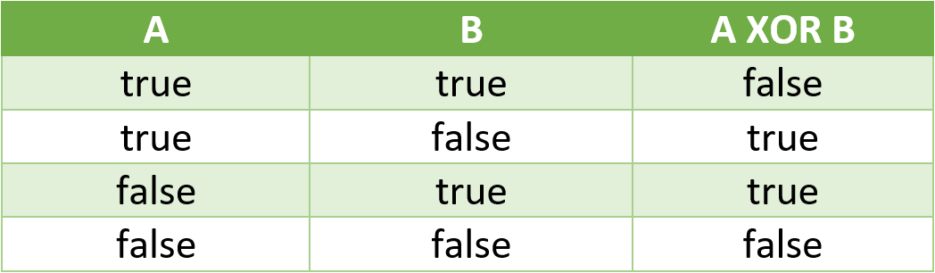
4. What do each of the following print
   1. Printf 2bc
   2. Prints 5bc
   3. Printf 5bc
   4. Prints bc5
   5. Prints bc23
5. to find the square root of c, find the roots of x^2 + 0x - c
6. It divides by r then multiplies by r (instead of dividing by r *r). Use parentheses: double force = G * mass1 * mass2 / (r * r);
7. Distance.java

public class Distance {

public static void main(String[] args) {

int x = Integer.parseInt(args[0]);

int y = Integer.parseInt(args[1]);

// compute distance to (0, 0)

double dist = Math.sqrt(x * x + y * y);

// output distance

System.out.println("distance from (" + x + ", " + y + ") to (0, 0) = " + dist);

}

}

1. SumOfTwoDice.java

public class SumOfTwoDice {

public static void main(String[] args) {

int sides = 6;

int a = 1 + (int) (Math.random() * sides);

int b = 1 + (int) (Math.random() * sides);

int sum = a + b;

System.out.println(sum);

}

}

1. SumOfSines.java

public class SumOfSines {

public static void main(String[] args) {

double degrees = Double.parseDouble(args[0]);

double radians = Math.toRadians(degrees);

double sum = Math.sin(2 * radians) + Math.sin(3 * radians);

System.out.println(sum);

}

}

1. SpringSeason.java

public class SpringSeason {

public static void main(String[] args) {

int month = Integer.parseInt(args[0]);

int day = Integer.parseInt(args[1]);

boolean isSpring = (month == 3 && day >= 20 && day <= 31)

|| (month == 4 && day >= 1 && day <= 30)

|| (month == 5 && day >= 1 && day <= 31)

|| (month == 6 && day >= 1 && day <= 20);

System.out.println(isSpring);

}

}